**Types and brands of laptops**

**Laptops**

**-Lenovo**

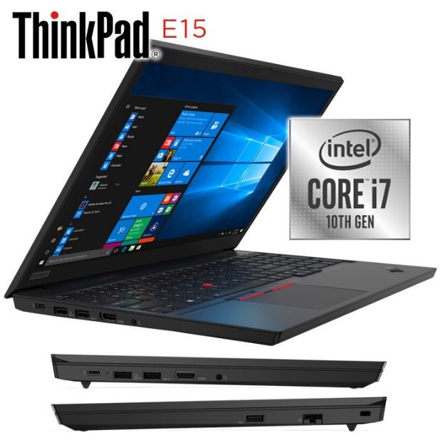

Lenovo ThinkPad Gen E15

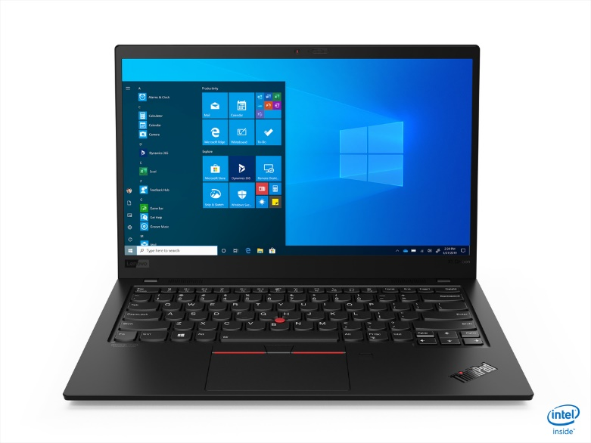

Lenovo ThinkPad X1 Carbon

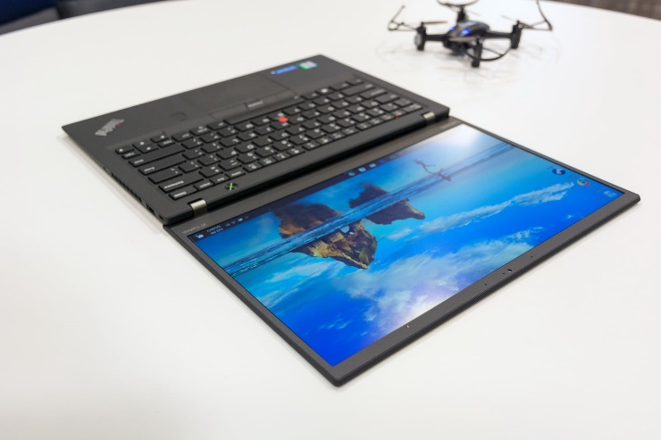

Lenovo ThinkPad Yoga C950

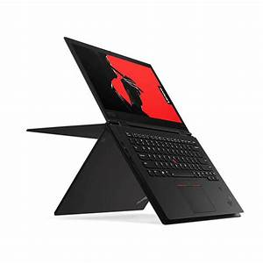

Lenovo ThinkPad X1 Yoga 6 Gen

Accer

Acer Chromebook 314 - CB314-1HT-C7C0

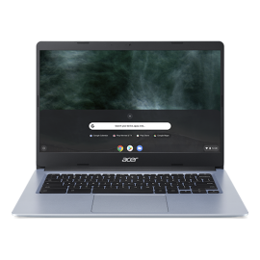

* Chrome OS
* Intel® Celeron® N4000 processor Dual-core 1.10 GHz
* Intel® UHD Graphics 600 shared memory
* 14" HD (1366 x 786) 16:9
* 4 GB, LPDDR4
* 64 GB Flash Memory

## [Swift 3 Laptop - SF314-57-59EY](https://store.acer.com/en-us/laptops/swift-3-laptop-sf314-57-59ey)

## F:\acer-swift-3-sf314-57-gray-main.png

* Windows 10 Home
* Intel® Core™ i5-1035G1 processor Quad-core 1 GHz
* Intel® UHD Graphics shared memory
* 14" Full HD (1920 x 1080) 16:9 IPS
* 8 GB, LPDDR4
* 256 GB SSD
* Intel® Core™ i5 processor

## [Aspire 7 Notebook - A715-41G-R7X4](https://store.acer.com/en-us/laptops/aspire-7-notebook-a715-41g-r7x4)

## F:\aspire-7-a715-75g-41g-black-gallery-01.png

* Windows 10 Home
* AMD Ryzen 5 3550H processor Quad-core 2.10 GHz
* NVIDIA® GeForce® GTX 1650 with 4 GB dedicated memory
* 15.6" Full HD (1920 x 1080) 16:9
* 8 GB, DDR4 SDRAM
* 512 GB SSD

## [Aspire 7 Laptop - A715-75G-544V](https://store.acer.com/en-us/laptops/aspire-7-laptop-a715-75g-544v)

## F:\aspire-7-a715-75g-41g-black-gallery-01_1.png

* Windows 10 Home
* Intel® Core™ i5-9300H processor Quad-core 2.40 GHz
* NVIDIA® GeForce® GTX 1650 with 4 GB dedicated memory
* 15.6" Full HD (1920 x 1080) 16:9
* 8 GB, DDR4 SDRAM
* 512 GB SSD

Dell

Mac

## MacBook Pro

## F:\vpavic_161031_1256_0075.0.jpg

* 13.3-inch Retina display[1](https://www.apple.com/mac/#footnote-2)
* Up to 4-core Intel Core i7 processor
* Up to 32GB memory
* Up to 4TB storage[2](https://www.apple.com/mac/#footnote-3)
* Up to 10 hours battery life[3](https://www.apple.com/mac/#footnote-4)
* Touch Bar and Touch ID
* Backlit Magic Keyboard

MacBook Air

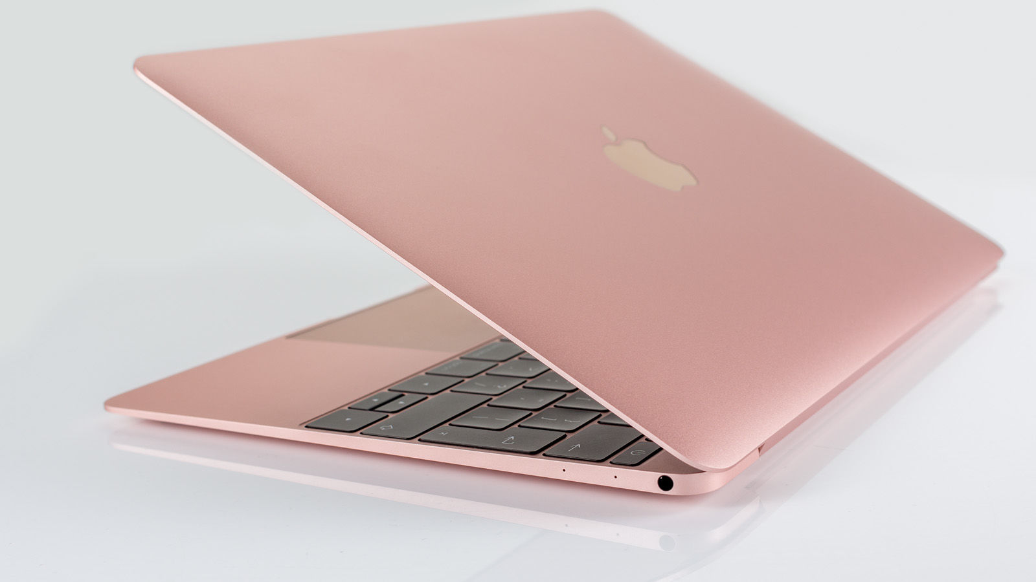

* 13.3-inch Retina display[1](https://www.apple.com/mac/#footnote-2)
* Up to 4-core Intel Core i7 processor
* Up to 16GB memory
* Up to 2TB storage[2](https://www.apple.com/mac/#footnote-3)
* Up to 11 hours battery life[3](https://www.apple.com/mac/#footnote-4)
* Touch ID
* Backlit Magic Keyboard

### MacBook Pro 16”

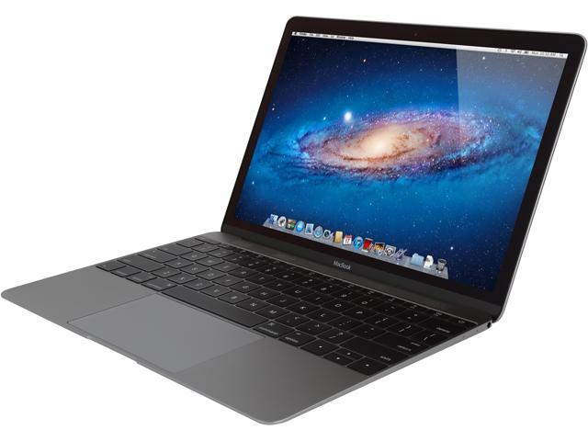

* 16-inch Retina display[1](https://www.apple.com/mac/#footnote-2)
* Up to 8-core Intel Core i9 processor
* Up to 64GB memory
* Up to 8TB storage[2](https://www.apple.com/mac/#footnote-3)
* Up to 11 hours battery life[3](https://www.apple.com/mac/#footnote-4)
* Touch Bar and Touch ID
* Backlit Magic Keyboard

Desktops